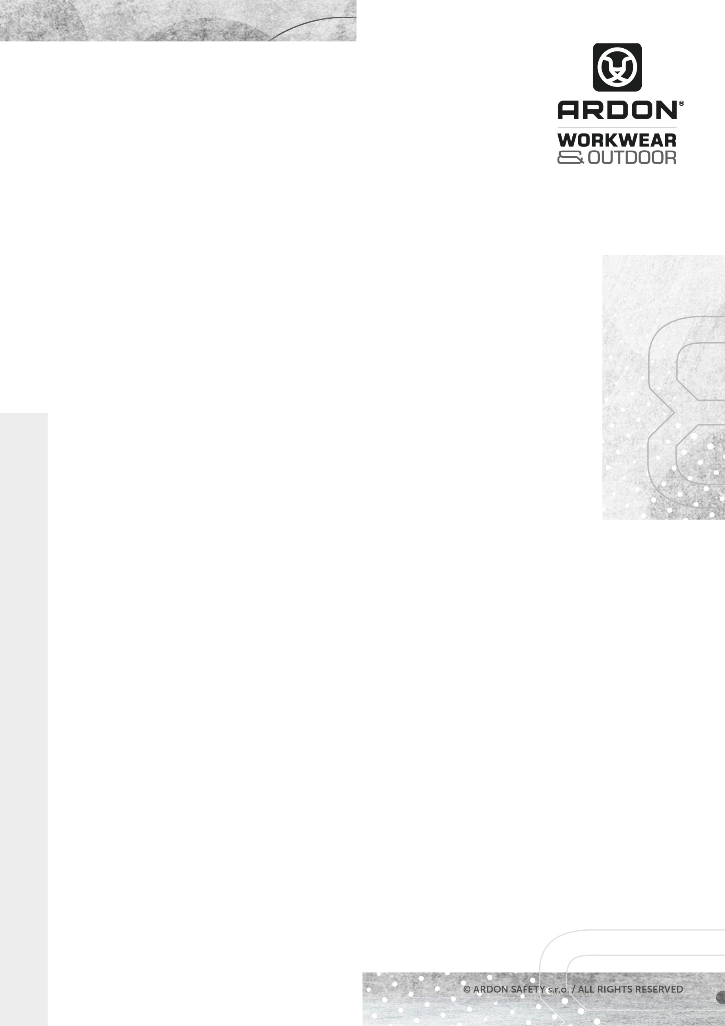
ARDON®CREATRON®
SWEATSHIRT

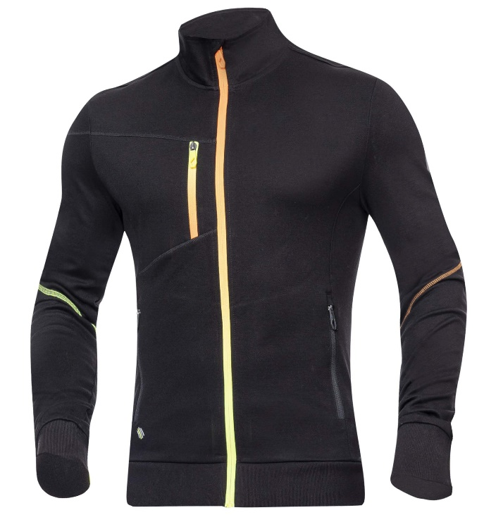
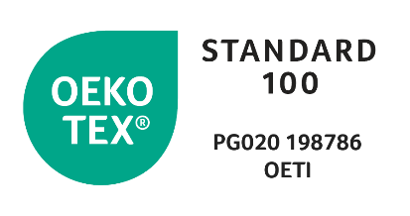
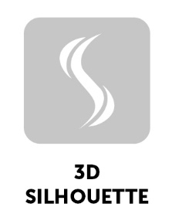
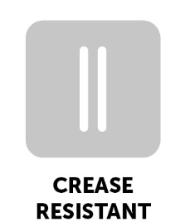

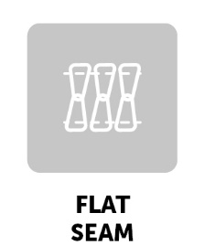

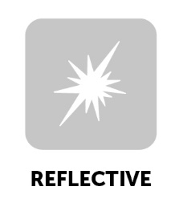
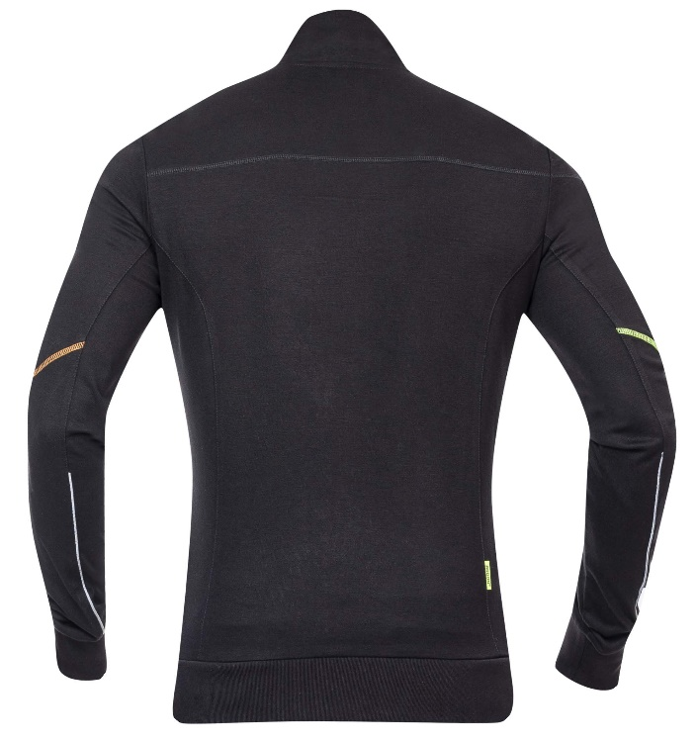
TECHNICAL DATA SHEET

ARDON®CREATRON®
SWEATSHIRT

ARTICLE H6670 (black-neon)
MATERIAL ARDON®TOPLYRON, 68 % rayon, 27 % nylon, 5 % spandex
GRAMMAGE 280 g/m²
SIZE S-4XL H6671
XS-5XL H6670

DESCRIPTION
This stretch sweatshirt with a stand-up collar made of the ARDONRTOPLYRON technical material, which is of extreme high quality, keeps a stable shape, and is wrinkle-free and pleasant to the touch at the same time. Thanks to its ability to repel dust particles, the materiál is not susceptible to static electricity, is breathable and quick-drying. The sweatshirt has an anatomically shaped functional SLIM FIT cut, is equipped with a comfortable continuous zipper fastening with a chin guard; it has one 1 zipper chest pocket and 2 zipper side pockets. High-visibility segmented strips complete the design. The sweatshirt is suitable for demanding outdoor activities, work and leisure.
This personal protective equipment is in conformity with the requirements of the following harmonised standard:

ČSN EN ISO 13688:2013 – Protective clothing – General requirements

The self-certification was carried out on the basis of the technical documentation of the product and practical tests of ergonomics propreties of the product by Ardon Safety s.r.o. on 25. 09. 2022

The CREATRON Collection meets health requirements and is OEKO-TEX®Standard 100 certified, PG020 certificate 198789 OETI.

TECHNICAL DATA SHEET

NUMBER OF PIECES IN CARTON 20 pcs
CARTON WEIGHT 20 kg
CARTON SIZE 0,078 m³
UNIT PACKAGING 1 ks

The service life depends on the rate of use and the rate of wear in the given
conditions. Inapropriate storage conditions, improper maintenance and care
reduce the service life. The warranty period is 24 months. Under no circumstances
should the warranty period be confused with the service lefe of the product. With
Intensive use, the service life may be shorter than the warranty provided.

The product does not contain any substances in concentrations that are known or
suspected to have an adverse effect on the user´s hygiene of health. However, skin
irritation is not impossible for sensitive people, in which case do not continue to
use the garment. Avoid the fire and sources of intense heat. No accessories or
replacement pants are intended for these garments. If the garment is not in use, it
Is recommended to store it in a dry and well-ventilated area away from direct
Sunlight. Transport best in original packaging, protect from moisture and extreme
temperatures. Dispose ecologically after use.
TECHNICAL DATA SHEET

TECHNICAL DATA SHEET

