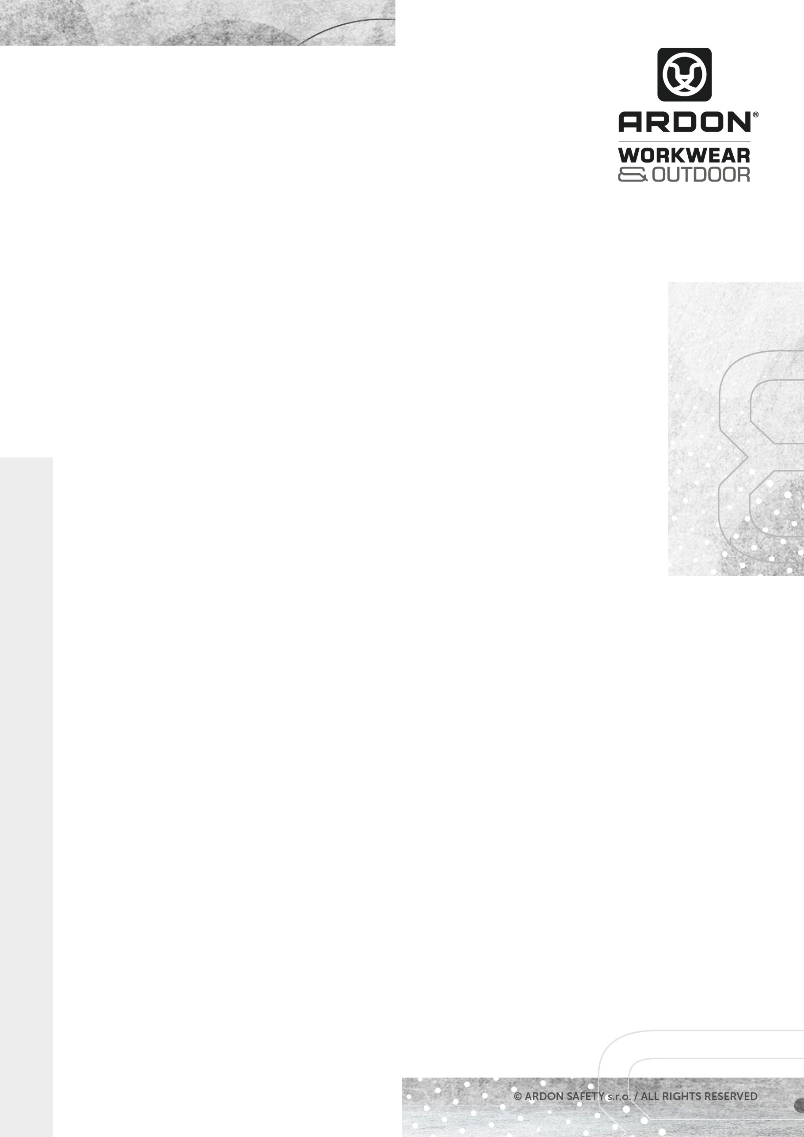
ARDON®CREATRON®
JACKET

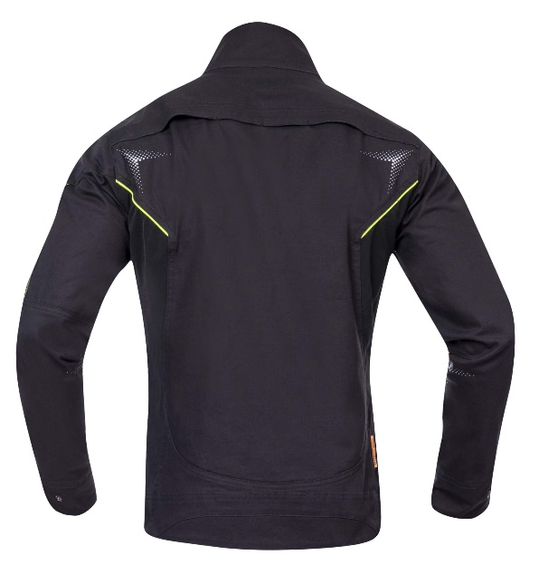

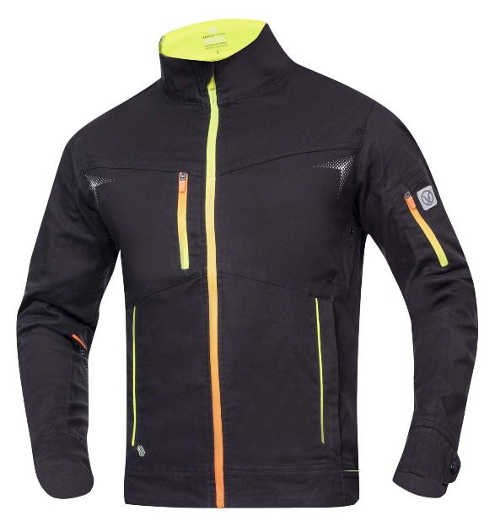

TECHNICAL DATA SHEET

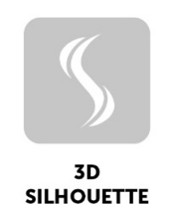
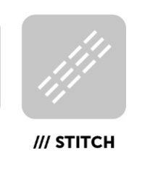

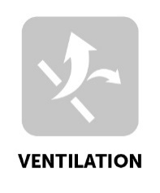
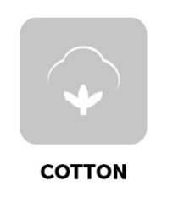
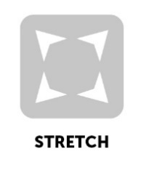

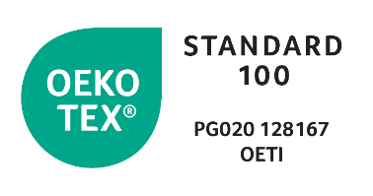
ARDON®CREATRON®
JACKET

ARTICLE H6649 (black-neon)
MATERIAL 98 % cotton, 2 % elastane, Amalytton®, canvas
GRAMMAGE 250 g/m²
SIZE S – 4XL

DESCRIPTION
This stretch cotton working jacket is made from the special Amalytton® material that features increased strength and a smooth, soft surface. The reduced grammage means the jacket is very pleasant to wear, which you will appreciate not just in summer when it is hot. The exposed areas are made of the Tabiflex® extra durable and four-way stretch material. The jacket with a stand-up collar has a highly functional ergonomic 3D cut that accentuates the silhouette. It features continuous zip fastening with a chin guard, 1 zipped chest pocket, 1 zipped pocket on the left sleeve, 2 zipped side pockets, adjustable width of the sleeves and bottom hem of the blouse via buttons. The upper left part of the jacket is designed to bear a company logo. The back of the jacket has functional ventilation. Dynamic high-visibility 3D printing and accessories provide increased user visibility.
This personal protective equipment is in conformity with the requirements of the following harmonised standard:
TECHNICAL DATA SHEET

ČSN EN ISO 13688:2013 – Protective clothing - General requirements
PPE of simple design against the minimum risks that may be quickly
and safety recognised by the user.

The self-certification was carried out on the basis of the technical documentation of the product and practical tests of ergonomics propreties of the product by Ardon Safety s.r.o. on 20 January 2021.

The CREATRON Collection meets health requirements and is OEKO-TEX®Standard 100 certified, PG020 certificate 128167 OETI.

NUMBER OF PIECES IN CARTON 20 pcs
CARTON WEIGHT 20 kg
CARTON SIZE 0,078 m³
UNIT PACKAGING 1 pc

The service life depends on the rate of use and the rate of wear in the given
conditions. Inapropriate storage conditions, improper maintenance and care
reduce the service life. The warranty period is 24 months. Under no circumstances
should the warranty period be confused with the service lefe of the product. With
Intensive use, the service life may be shorter than the warranty provided.

The product does not contain any substances in concentrations that are known or
suspected to have an adverse effect on the user´s hygiene of health. However, skin
irritation is not impossible for sensitive people, in which case do not continue to
use the garment. Avoid the fire and sources of intense heat. No accessories or
replacement pants are intended for these garments. If the garment is not in use, it
Is recommended to store it in a dry and well-ventilated area away from direct
Sunlight. Transport best in original packaging, protect from moisture and extreme
temperatures. Dispose ecologically after use.

TECHNICAL DATA SHEET
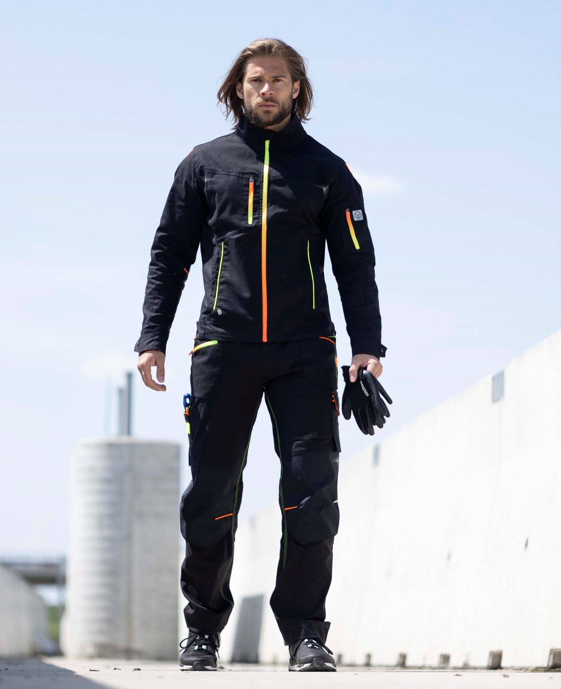
TECHNICAL DATA SHEET

