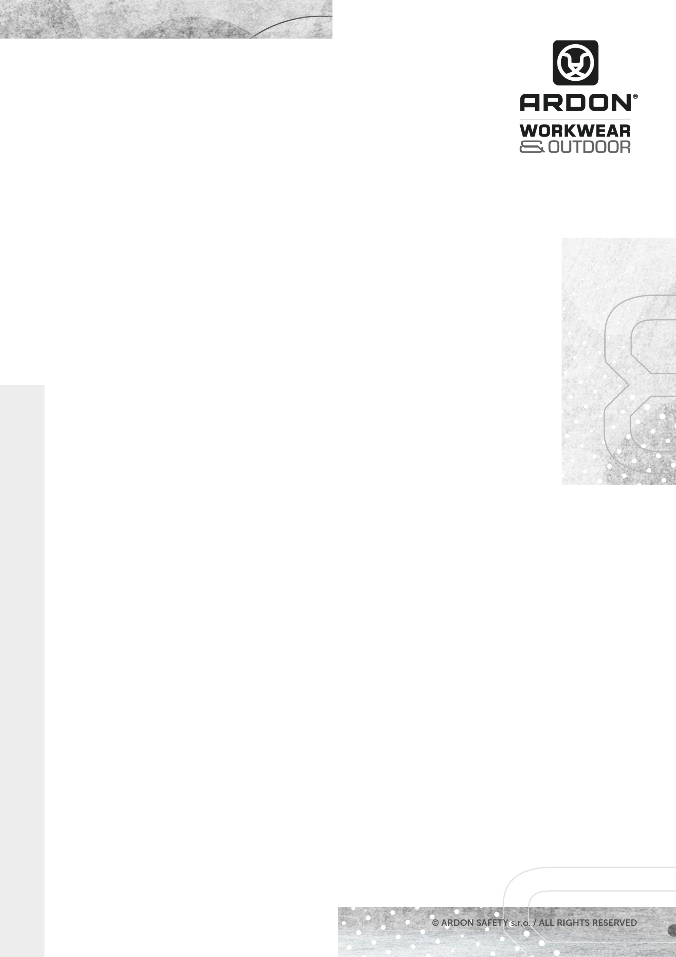


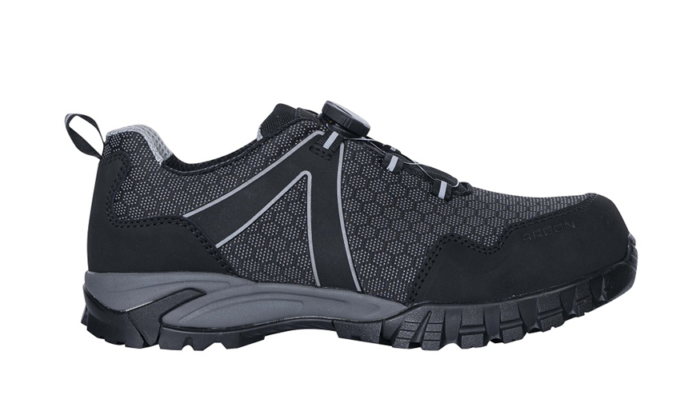

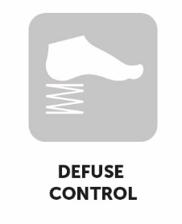

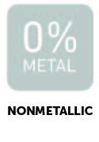
ARDON®BRICKLOW S3
SAFETY SHOES

TECHNICAL SHEET
DIMENSIONS | 38-39 | 40-43 | 44-48
Carton H x W x D (cm) | 31.5 x 41.5 x 61.5 | 33.5 x 43.5 x 61.5 | 37 x 43.5 x 64
Carton (cbm) | 0,0804 | 0,0896 | 0,103

ARDON®BRICKLOW S3
SIZE

UNIT

PACKAGE
Units in a carton
Units in a box
38-48

pair
10 pairs
1 pair

DESCRIPTION
Safety boot with an upper made of durable fabric and leather in the toe and heel area, with hydrophobic treatment, with a composite toe cap and Kevlar insole.
Size EUR | 35 | 36 | 37 | 38 | 39 | 40 | 41 | 42 | 43 | 44 | 45 | 46 | 47 | 48 | 49 | 50 | 51
Insole length mm | - | - | - | 250 | 257 | 264 | 270 | 277 | 284 | 290 | 297 | 304 | 310 | 317 | - | - | -
Foot length cm | - | - | - | 24,5 | 25,2 | 25,9 | 26,5 | 27,2 | 27,9 | 28,5 | 29,2 | 29,9 | 30,5 | 31,2 | - | - | -

Durable fabric / leather
MESH-type laminated breathable fabric
EVA/rubber, bonded technology
604 composite
Kevlar
ANATOMIC FOAM – anatomically shaped from EVA foam

MATERIAL
Upper
Lining
Sole
Toe cap
Plate
Insole

G3395
ARTICLE
SAFETY SHOES
TECHNICAL SHEET
TECHNICAL SHEET

NORMS

(EU) 2016/425
EN ISO 20345:2011 Personal protective equipment - Safety footwear

Category: S3 HRO SRC

Categories | EN ISO 20345
E - energy absorption in the heel area | ✓
FO - resistance to oils and fuels | ✓
A - antistatic footwear | ✓
SRC - resistance to slipping on ceramic floor tiles with SLS and on steel floors with glycerin | ✓
WR - upper resistant to water | ✓
Safety toe cap for toe protection | ✓
P - resistance to punctures (protective insole) | ✓
SRA - slip resistance ceramic floor tiles with SLS
HRO - resistance to contact heatup to 300 °C | ✓
insulation of the bottom of the shoe against heat
insulation of the bottom of the shoe against the cold
Splatters of molten metal
ESD – shoe protects against electrostatic discharge and can be used on EPA premises
The shoes do not contain metal parts
-
-
-



CODE | EAN | CARTON WEIGHT  (KG) | UNIT WEIGHT  (KG)
G3395/38 | 8592390162731 | 12.35 | 1.235
G3395/39 | 8592390162748 | 12.90 | 1.290
G3395/40 | 8592390162755 | 13.10 | 1.310
G3395/41 | 8592390162762 | 13.30 | 1.330
G3395/42 | 8592390162779 | 13.50 | 1.350
G3395/43 | 8592390162786 | 13.90 | 1.390
G3395/44 | 8592390162793 | 14.85 | 1.485
G3395/45 | 8592390162809 | 15.20 | 1.520
G3395/46 | 8592390162816 | 15.40 | 1.540
G3395/47 | 8592390162823 | 15.90 | 1.590
G3395/48 | 8592390162830 | 16.40 | 1.640

TECHNICÝ LIST

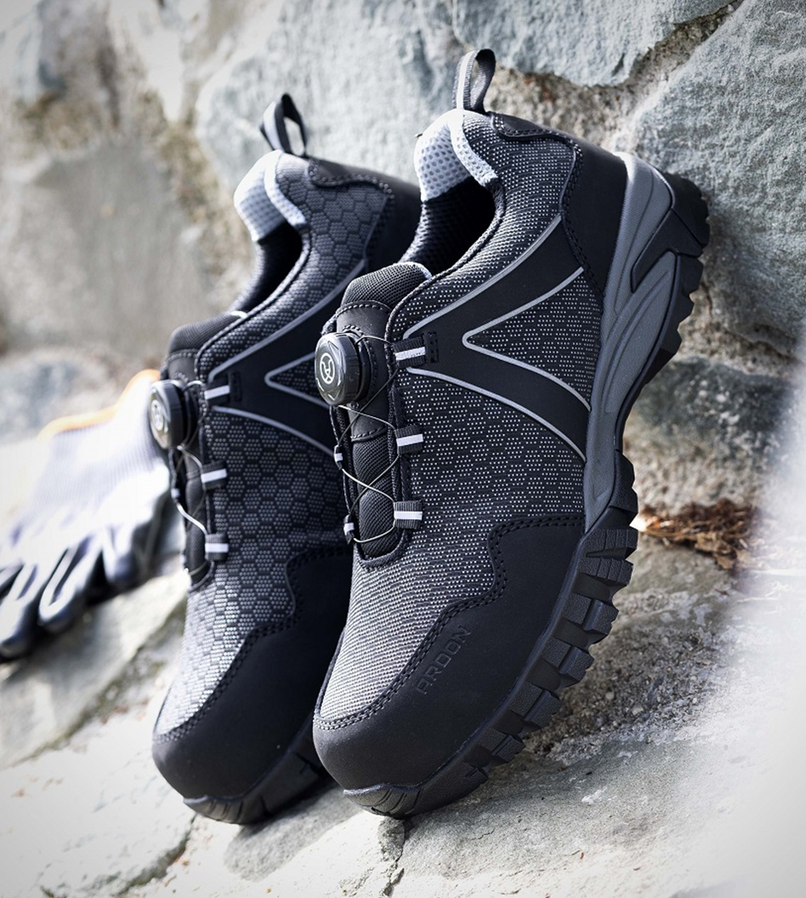

TECHNICÝ LIST

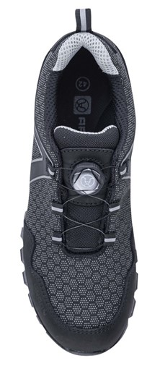
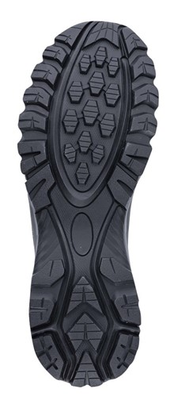

TECHNICAL SHEET

